**EXPERIMENT - 4**

**AIM**: Latent Semantic Indexing

**THEORY**:

Latent Semantic Analysis (LSA) involves creating structured data from a collection of unstructured texts. Before getting into the concept of LSA, let us have a quick intuitive understanding of the concept. When we write anything like text, the words are not chosen randomly from a vocabulary.

Rather, we think about a theme (or topic) and then chose words such that we can express our thoughts to others in a more meaningful way. This theme or topic is usually considered as a latent dimension.

It is latent because we can’t see the dimension explicitly. Rather, we understand it only after going through the text. This means that most of the words are semantically linked to other words to express a theme. So, if words are occurring in a collection of documents with varying frequencies, it should indicate how different people try to express themselves using different words and different topics or themes.

In other words, word frequencies in different documents play a key role in extracting the latent topics. LSA tries to extract the dimensions using a machine learning algorithm called Singular Value Decomposition or SVD.

Singular Value Decomposition or SVD is essentially a matrix factorization technique. In this method, any matrix can be decomposed into three parts as shown below.

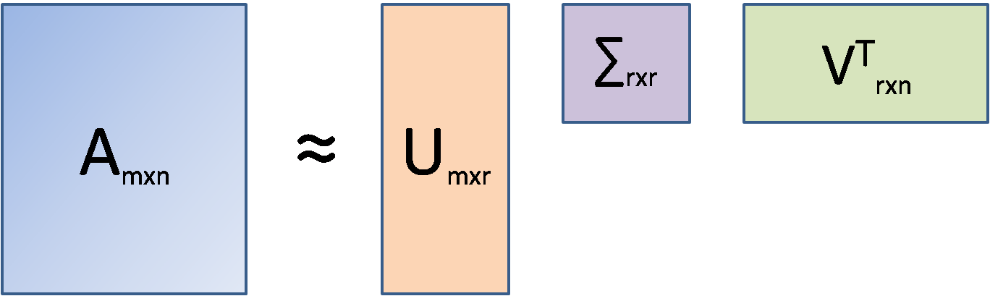

Here, A is the document-term matrix (documents in the rows(m), unique words in the columns(n), and frequencies at the intersections of documents and words). It is to be kept in mind that in LSA, the original document-term matrix is approximated by way of multiplying three other matrices, i.e., U, ∑ and VT. Here, r is the number of aspects or topics. Once we fix r (r<<n) and run SVD, the outcome that comes out is called Truncated SVD and LSA is essentially a truncated SVD only.

SVD is used in such situations because, unlike PCA, SVD does not require a correlation matrix or a covariance matrix to decompose. In that sense, SVD is free from any normality assumption of data (covariance calculation assumes a normal distribution of data). The U matrix is the document-aspect matrix, V is the word-aspect matrix, and ∑ is the diagonal matrix of the singular values. Similar to PCA, SVD also combines columns of the original matrix linearly to arrive at the U matrix. To arrive at the V matrix, SVD combines the rows of the original matrix linearly. Thus, from a sparse document-term matrix, it is possible to get a dense document-aspect matrix that can be used for either document clustering or document classification using available ML tools. The V matrix, on the other hand, is the word embedding matrix (i.e. each and every word is expressed by r floating-point numbers) and this matrix can be used in other sequential modeling tasks.

**CODE:**

| import numpy as np  import pandas as pd  import matplotlib.pyplot as plt  pd.set_option("display.max_colwidth", 200)  from sklearn.datasets import fetch_20newsgroups  dataset = fetch_20newsgroups(shuffle=True, random_state=1, remove=('headers', 'footers', 'quotes'))  documents = dataset.data  Dataset.target_names |
| --- |

**OUTPUT**

| ['alt.atheism',  'comp.graphics',  'comp.os.ms-windows.misc',  'comp.sys.ibm.pc.hardware',  'comp.sys.mac.hardware',  'comp.windows.x',  'misc.forsale',  'rec.autos',  'rec.motorcycles',  'rec.sport.baseball',  'rec.sport.hockey',  'sci.crypt',  'sci.electronics',  'sci.med',  'sci.space',  'soc.religion.christian',  'talk.politics.guns',  'talk.politics.mideast',  'talk.politics.misc',  'talk.religion.misc'] |
| --- |

**CODE:**

| news_df = pd.DataFrame({'document':documents})  # remove everything except alphabets`  news_df['clean_doc'] = news_df['document'].str.replace("[^a-zA-Z]", " ")  # remove short words  news_df['clean_doc']=news_df['clean_doc'].apply(lambda x:' '.join([w for w in x.split() if len(w)>3]))  # make all text lowercase  news_df['clean_doc'] = news_df['clean_doc'].apply(lambda x: x.lower())  from nltk.corpus import stopwords  import nltk  nltk.download('stopwords')  stopwords = nltk.corpus.stopwords.words('english')  # stop_words = stopwords.words('english')  # tokenization  tokenized_doc = news_df['clean_doc'].apply(lambda x: x.split())  # remove stop-words  tokenized_doc = tokenized_doc.apply(lambda x: [item for item in x if item not in stopwords])  # de-tokenization  detokenized_doc = []  for i in range(len(news_df)):  t = ' '.join(tokenized_doc[i])  detokenized_doc.append(t)  news_df['clean_doc'] = detokenized_doc  from sklearn.feature_extraction.text import TfidfVectorizer  vectorizer = TfidfVectorizer(stop_words='english', max_features= 1000, max_df = 0.5, smooth_idf=True)  X = vectorizer.fit_transform(news_df['clean_doc'])  X.shape  from sklearn.decomposition import TruncatedSVD  # SVD represent documents and terms in vectors  svd_model = TruncatedSVD(n_components=20, algorithm='randomized', n_iter=100, random_state=122)  svd_model.fit(X)  terms = vectorizer.get_feature_names_out()  for i, comp in enumerate(svd_model.components_):  terms_comp = zip(terms, comp)  sorted_terms = sorted(terms_comp, key= lambda x:x[1],  reverse=True)[:7]  print("Topic "+str(i)+": ", end="")  for t in sorted_terms:  print(t[0], end="")  print(" ", end="\t")  print() |
| --- |

**OUTPUT:**

| Topic 0: like know people think good time thanks  Topic 1: thanks windows card drive mail file advance  Topic 2: game team year games season players good  Topic 3: drive scsi hard disk card drives problem  Topic 4: windows file window files program using problem  Topic 5: chip government mail space information encryption data  Topic 6: like bike chip know sounds looks look  Topic 7: card video sale monitor offer price jesus  Topic 8: know card chip government video people clipper  Topic 9: good know time bike jesus problem work  Topic 10: think chip good thanks clipper encryption need  Topic 11: thanks good right bike problem people time  Topic 12: good people windows know file sale files  Topic 13: space think know nasa problem year israel  Topic 14: space good card people time nasa thanks  Topic 15: people problem window time game want work  Topic 16: time bike right windows file need really  Topic 17: time problem file think israel long mail  Topic 18: file need card files right problem good  Topic 19: problem file thanks used space chip sale |
| --- |

**CODE:**

| import umap.umap_ as umap  X_topics = svd_model.fit_transform(X)  embedding = umap.UMAP(n_neighbors=150, min_dist=0.5, random_state=12).fit_transform(X_topics)  plt.figure(figsize=(7,5))  plt.scatter(embedding[:, 0], embedding[:, 1],  c = dataset.target,  s = 10, # size  edgecolor='none' )  plt.show() |
| --- |

**OUTPUT:**

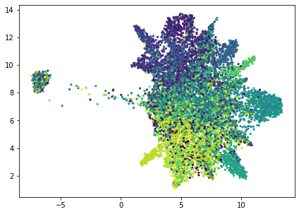

**CONCLUSION**: Understanding the context behind a sentence is an important part behind understanding its meaning. This comes naturally to the human brain, but is difficult for the computer to understand. Latent Semantic Analysis (LSA) is what comes in place to help the computer understand the context while during NLP. In this experiment, we have implemented LSA using python.